**Connecting to Oracle Database 18c XE**

**Connecting via SQL Developer**

To connect to Oracle Database 18c XE, I highly recommend to [download and install SQL Developer](https://oracle.com/sqldeveloper) (please see the [installation instructions for SQL Developer](https://docs.oracle.com/en/database/oracle/sql-developer/19.2/rptig/installing-sql-developer.html#GUID-E2AE9731-C596-47C3-84EC-CFB06A3138B6)).

Open a new connection window by clicking on the green + sign at the top left under “**Connections**“.

[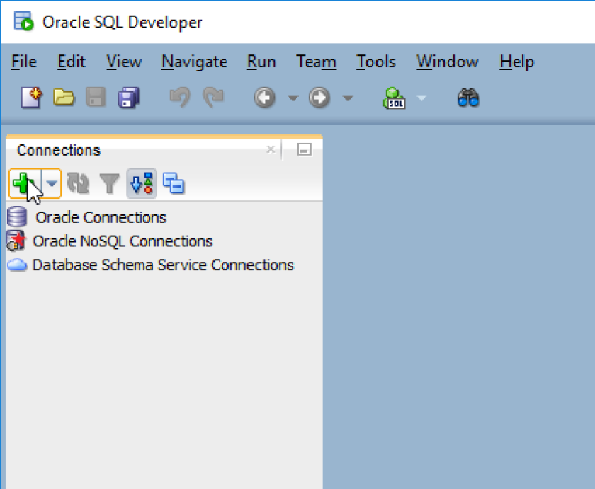](https://venzi.files.wordpress.com/2019/08/oracle-database-18c-xe-sqldeveloper-new-connection.png)

Then enter the connection details for XE.

[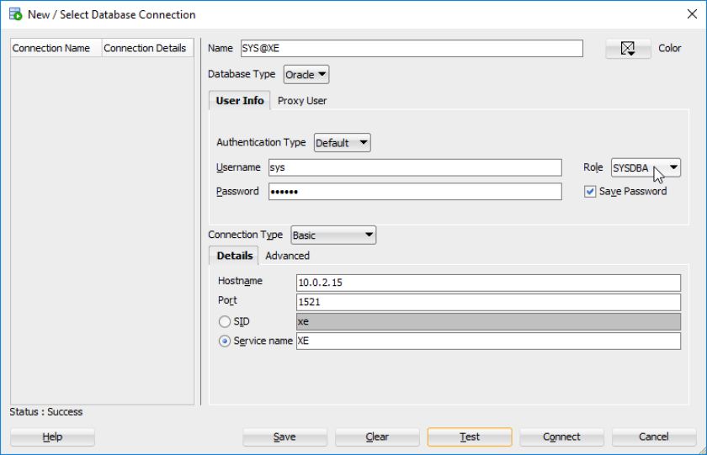](https://venzi.files.wordpress.com/2019/08/oracle-database-18c-xe-sqldeveloper-xe-connection-details.png)

Don’t forget to change the role to SYSDBA if you are trying to connect as SYS. Check the “**Save Password**” box, if you want SQL Developer to remember your password. Then click “**Connect**“.

A new SQL worksheet should have popped up and you are connected to Oracle Database 18c XE.

[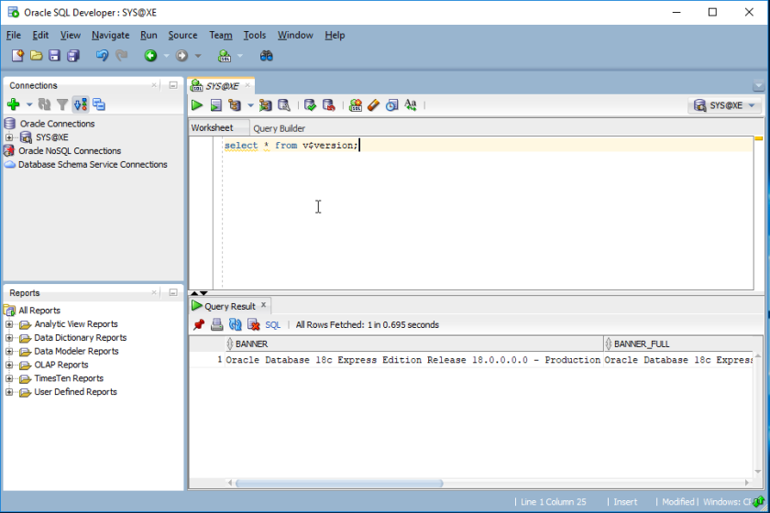](https://venzi.files.wordpress.com/2019/08/oracle-database-18c-xe-sqldeveloper-connection-success.png)

**Connecting via Command Prompt**

To connect to Oracle Database 18c XE via command prompt, fire up a command prompt and type sqlplus / as sysdba, which will connect you as SYS to the container database XE.

[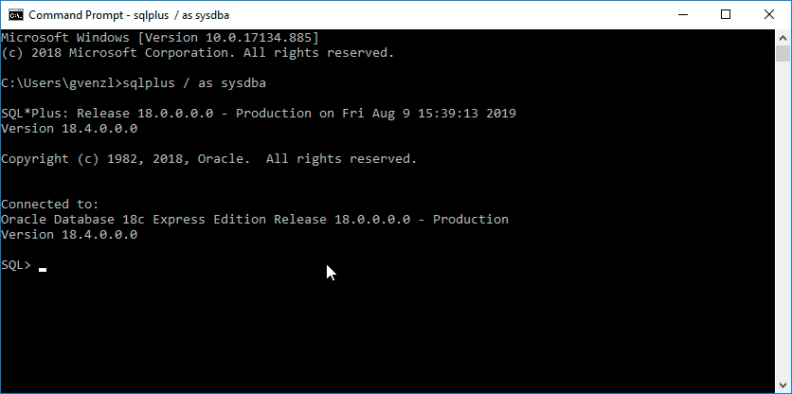](https://venzi.files.wordpress.com/2019/08/oracle-database-18c-xe-sqlplus-cdb.png)

You can switch to the pluggable database XEPDB1 by typing alter session set container=XEPDB1; You can confirm the container switch by typing show con_name which should return XEPDB1. If you do not see XEPDB1 but CDB$ROOT instead, you have not switched the container. Check for potential errors in your alter session command.

[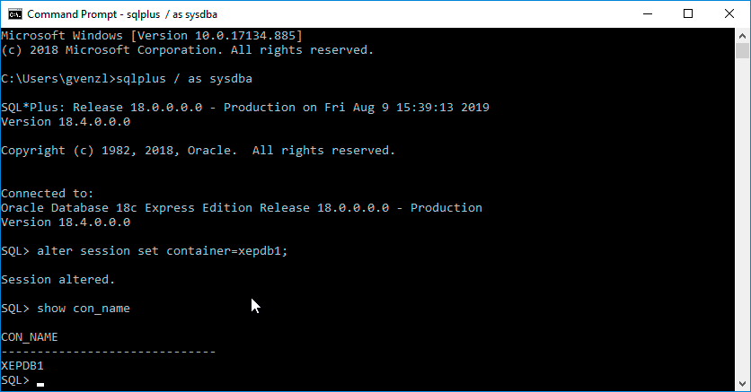](https://venzi.files.wordpress.com/2019/08/oracle-database-18c-xe-sqlplus-pdb.png)